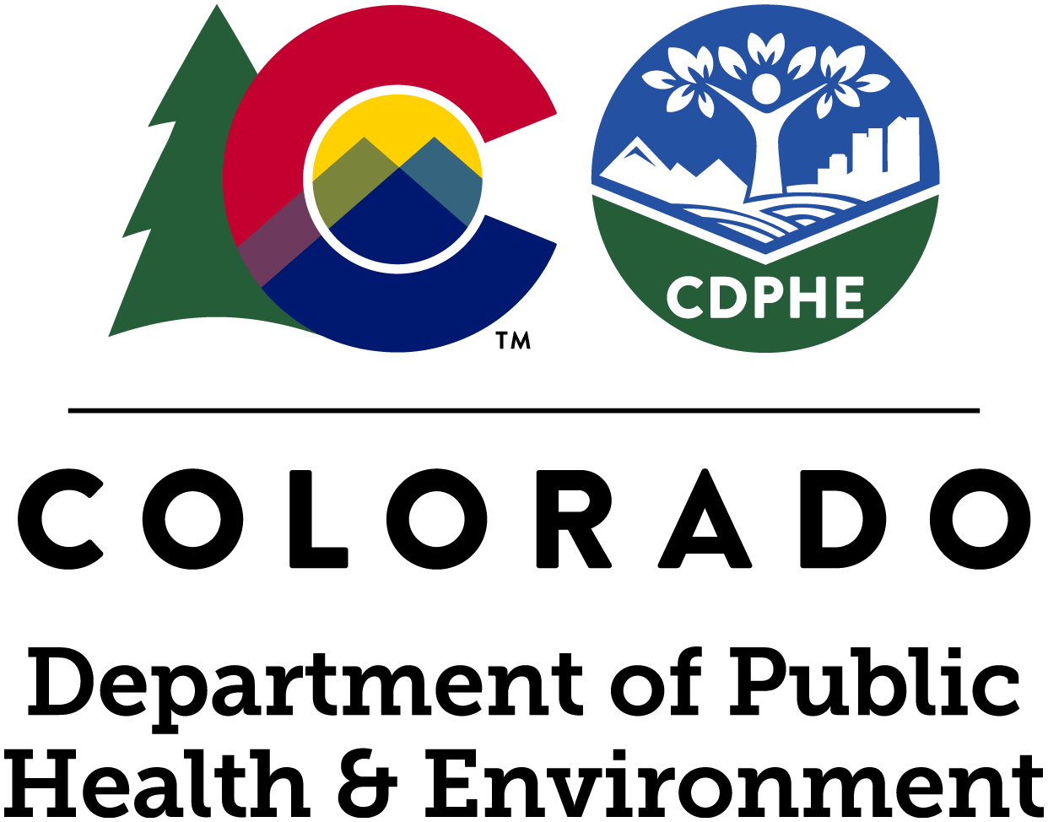 | COVID-19 GUIDANCE  Residential care facility holiday visitation

The Residential Care Strike Team encourages all residents and family members to celebrate their holidays differently this year. The COVID-19 public health emergency continues to rage in 2020 and cases are on the rise. The timing for our residential care facility residents could not be worse. After months of no and/or limited visitation, the desire to reestablish holiday traditions will be strong. Families can consider a variety of new options that are much safer for those who are at high risk of developing severe illness from COVID-19. For more information, a valuable resource was developed by the Colorado Dementia Partnership on how to re-think rituals around the holidays and how to plan a meaningful remote visit during COVID-19.

If you choose to have a holiday visit

For those that have chosen to have a holiday visit this year, there are a number of different ways that the gathering can be made safer. None of these methods are as safe as speaking to your loved ones remotely. Diligently consider the following:
- Family members should minimize potential risk before a holiday gathering. Those who are able should refrain from unnecessarily seeing other people, going out to eat, or participating in any other activity that may place you in close contact with persons outside the household for at least 14 days prior to the gathering. For more information about the incubation period, look at this timeline table.
- Check local and state ordinances to see if they allow for a holiday gathering via Colorado's Dial Framework.
- Consider holding your holiday celebration in an outdoor setting if possible. Gathering in doors has more risk. Furthermore, limiting indoor gathering prior your holiday gathering can reduce the risk of COVID 19 infection.
- Determine the length of the holiday celebration. The longer the celebration, the greater risk to everyone who participates.
- Communicate with the residential care facility. Let the facility know how long the resident will be out of the building. If you must visit in person, the Residential Care Strike Team recommends keeping the holiday gathering no longer than a few hours. For those gatherings that last overnight, the resident is then required to be put in quarantine for 14-days per state guidance.
- The Colorado Department of Public Health and Environment advises facilities to create internal policies for those visits that are not overnight to determine if the resident’s potential exposure warrants a 14-day quarantine.
- Make a plan with the facility for the resident’s return.
- Do not invite anyone who has been sick or has come in contact with anyone who has been sick. Many people who are able to spread COVID-19 do not have symptoms.
- It may be tough for family members to self-report illness and defer holiday plans with the rest of the family. Therefore, it may be a good idea to designate someone in the family, perhaps the hosting individual, to contact all anticipated guests prior to their arrival to ask if they have had any symptoms or contact with anyone who has been sick. This does not need to be a formal process and may include a quick text to check in.

Remember: All strategies only minimize risk, and while they are extremely important, they do not eliminate it!

During your holiday visit

- Follow state and local ordinances about socialization.
- Wear masks when not eating or drinking, store your mask safely when not in use, and socially distance at all times.
- Wash your hands regularly.
- Keep hand sanitizer accessible for everyone, particularly for those who are not mobile enough to get up and wash their hands often.
- Clean and disinfect frequently touched surfaces.
- Your behavior during this time could have an effect on everyone who attends.
- Combining measures improves the likelihood of not spreading the disease.
- Consider how the holiday meal is served to ensure social distancing at all times; for example; avoid having individuals walking in and out of the kitchen to serve themselves.

After your holiday visit

- Return to the facility during the time you planned and communicate with the facility to ensure a safe and easy return to the facility.
- Understand any changes that may need to be made as a result of the resident leaving the facility.
- Ensure your loved one understands the changes that may be necessary.
- If your loved one is required to quarantine upon return, stay in touch! Continue to talk on the phone, video conference, and use other such forms of meaningful communication.
- Follow the best practices of both infection and travel guidelines as found in the timeline table.

Instead of a holiday visit, bring your loved one a plate of food - but only your loved one - and communicate with the facility prior to delivering the food.

Other resources

CDC: Celebrating Thanksgiving

